Guide to using the
whistleblower system

WHISTLEBLOWER

Whistleblower tasks

Support
Any questions about using the whistleblower scheme can be directed to Whistleblower Partners support at +44 2039962344.
Using the system – whistleblowers
Enter [Insert the link listed at the top of the welcome letter] in your browser.
You will then be taken to the page where you can leave a message about the irregularities you have become aware of.
Enter as much information as you can and in as much detail as possible. You can attach documentation if you have it.
Finish by pressing 'Send'.

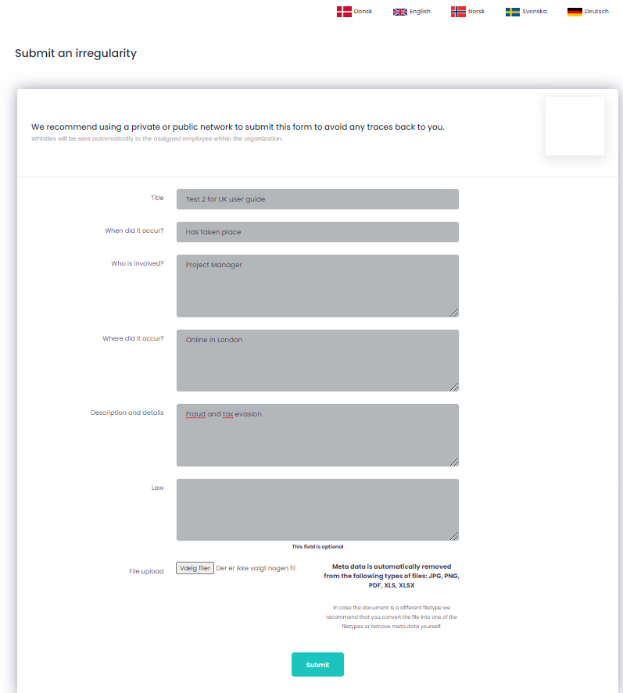

Note – you will now be shown a code and asked to write it down. It is VERY IMPORTANT that you write down the code, as it is your only way of accessing your message and seeing the response from the 'case manager'. The code is your personal code and cannot be recreated. However, if you lose it, you can re-enter your information.
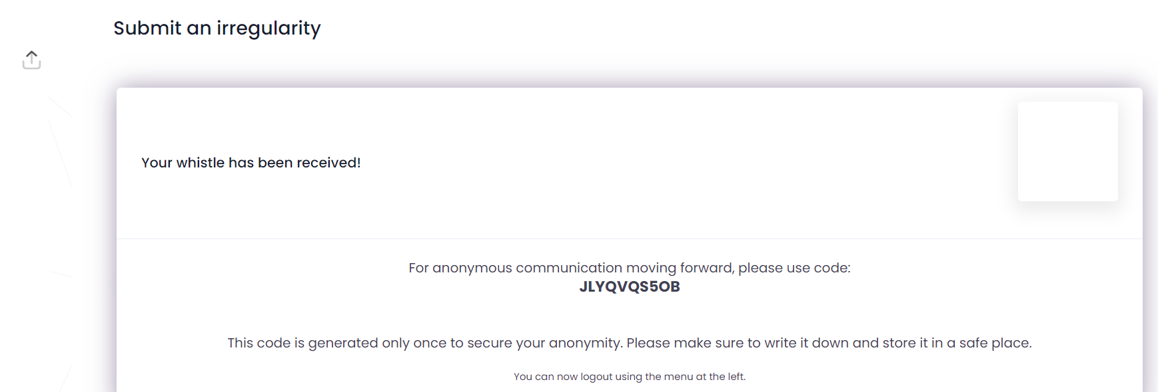

This code should be written down and saved. Use the code when accessing the system via https://nordicwhistle.whistleportal.eu.
Instead of 'email address' and 'password', use the ‘conversation code’.
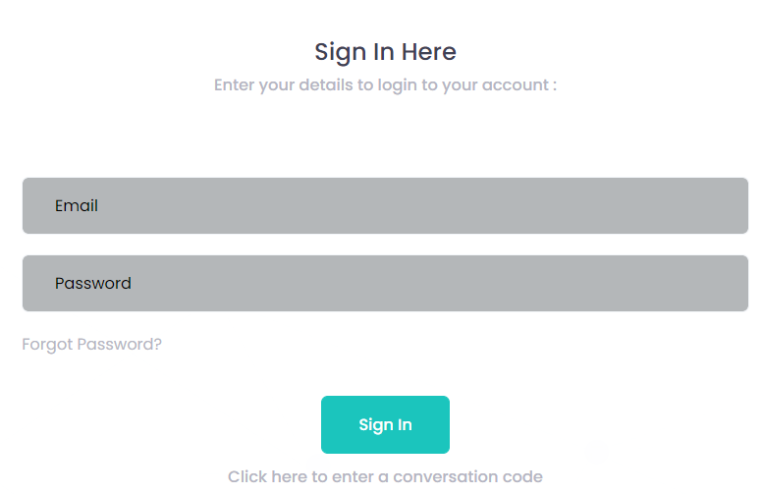

Enter your code now

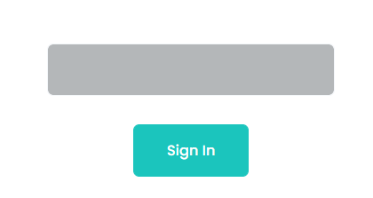
Enter code here

You will then enter your case and be able to see any messages from the 'case manager' in the timeline on the right of the screen.
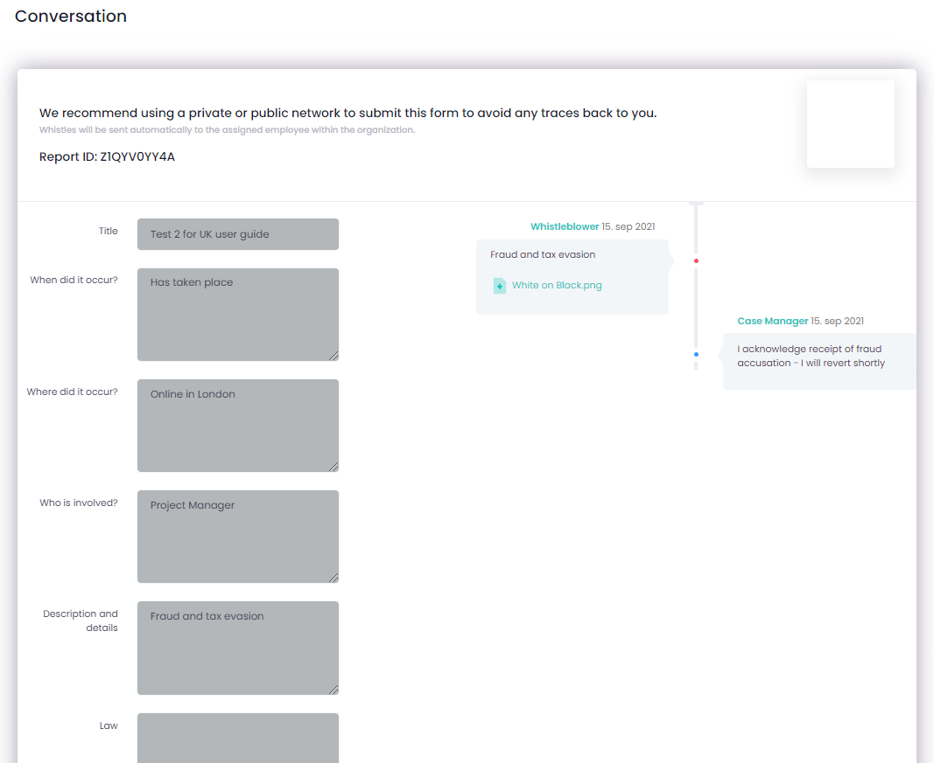

Description of Case Progress

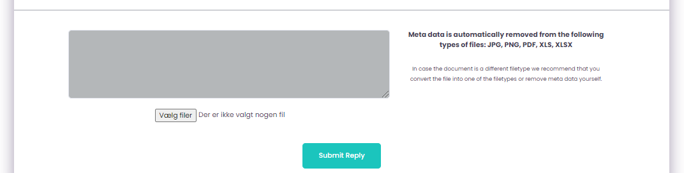
Enter any new comments in the dialogue with the case manager here, then press 'Submit reply'.

